[class name] – LABORATORY EXERCISE
Name:
Date:

Community Science- Project RattleCam on Zooniverse

After completing this laboratory, you should be able to:
- articulate the role of community (citizen) science.
- demonstrate systematic, detail-oriented observation skills.
- describe the reproductive biology of prairie rattlesnakes at a high elevation den.

Introduction:
Community science, also called citizen science, is a powerful tool that may be used to answer research questions that traditional studies, with a small number of researchers and limited funding, make unfeasible. This is particularly true of field studies where accessibility to study sites may be limited. Community science-based projects have the potential to improve research by increasing sample sizes, reducing costs and time required, and allowing scientists to study secretive, cryptic and rare species. In addition, community science makes science accessible to people of all education levels across the world, helping to promote an interest in science in everyone.
Zooniverse is a platform designed to support community science-based efforts. Scientists from a diverse array of fields are able to set up Zooniverse projects to engage community members to participate in scientific research. The database is user-friendly and supports a variety of users, from children exploring curiosity about the natural world to scientists conducting research, and even college students completing a lab assignment! Community science projects support an appreciation of the natural world and build community with other explorers of the natural world to promote conservation and scientific literacy.

Activity 1: Explore the Zooniverse Data Base

In this activity you will set up a free Zooniverse account so that you may participate in classifications.
- Navigate to the Zooniverse webpage from your computer. You will select the “Register” icon at the top right corner of the page

- Complete the registration pop up window to create an account. Be sure to keep track of your User name and Password in case you need to login multiple times to complete your classifications. Note: You will be using your account to submit verification of your classifications.
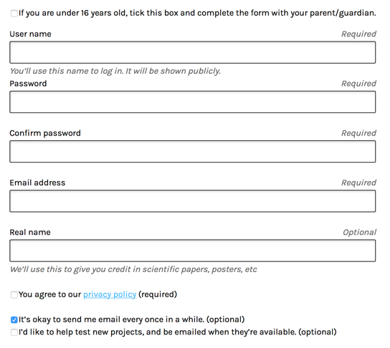

Username ________________________

Activity 2: Getting to Know Project RattleCam
Project RattleCam is a community science project engaging members to help the research team gain insight into Prairie Rattlesnake behavioral ecology by assessing rattlesnake activity observed in photographs taken by game cameras at a snake rookery in a rocky outcrop in high elevation Colorado. In this activity you will learn some basic background information you will need to participate in Project RattleCam where you will assist scientists in exploring the world of Prairie Rattlesnake social behavior.

1. Navigate to the Project RattleCam page on Zooniverse where you will select the “Learn more” icon.
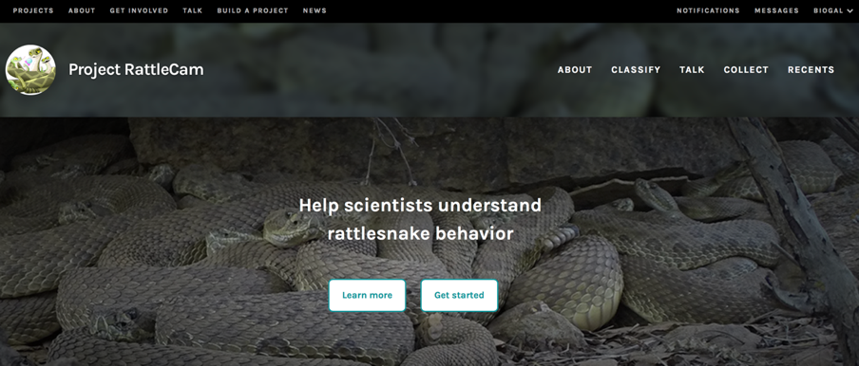
2. On the Welcome to Project RattleCam page watch the welcome video and answer the following questions.
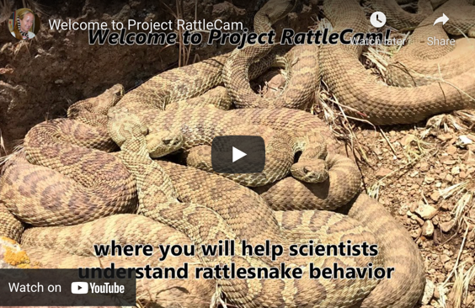

Where is the study site located?

Why are Prairie Rattlesnakes spending time at this site?

What are Prairie Rattlesnakes doing at this site in the summer?

Why did the researchers set up cameras?

What questions will your participation in the project help with?

1.

2.

3.

4.

3. Next, watch the Project RattleCam Tutorial video to learn how classifications work and answer the questions below.

What is a rookery?

What is the first question will you be asked when analyzing a photo from the game camera?

If you have a question on what type of animal you may see on an image, what can you do?

Do the researchers know what you will see on the images? Why or why not?

Activity 3: Explore the Field Guide
Become familiar with the tools available that will help you make accurate classifications. Keep in mind that this is an actual research project that is dependent on the accuracy of the data that you will be collecting. Let’s explore some common challenges so that you are prepared to accurately observe snakes and keep you from making missss-stakes!

Be mindful of common pitfalls where misclassifications may occur:
- Search image thoroughly. Rattlesnakes are cryptic, meaning they blend in well with their environment, so they may be difficult to spot. Make sure you carefully and systematically search the entire image for snakes. Use the zoom and scroll features to thoroughly search the image. Take your time as you get started and are learning how to find the snakes in the photographs. Once you get your search image down, you will become more accurate and efficient in your classifications.
- Shed snake skins can look like a snake, make sure you look closely and don’t confuse them with an actual snake.
- You may observe baby rattlesnakes. Since these snakes are small they can be easy to miss, especially in the background. Again, use zoom and scroll features to assist you in finding hard-to-see snakes.
- You may observe adults and/or baby rattlesnakes. Use the Field Guide to help you distinguish between the two.
- Be sure to reference the Field Guide if you have any questions.

The Field Guide tool is the main resource that will assist you with common questions or clarifications you will need in completing your classifications. We will begin by exploring the information in the Field Guide so you are prepared to make skilled observations and are familiar with the characteristics you will need to assess the images. Read the content in the Field Guide and answer the following questions to ensure your comprehension.

1. Click on the “Field Guide” icon on the right side of your screen. The Field Guide window will appear.
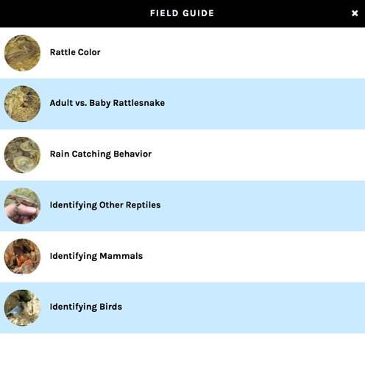
2. Explore each of the sections of the Field Guide and answer the questions below about what you will be looking for in the photos you classify.

Field Guide Category | What to look for?
Rattle color | Some rattlesnakes will be marked with paint in their rattles. What is the purpose of the different color patterns?
Adult vs Baby | What is the pipe I see in the photo? Should you mark it as a snake?
Adult vs Baby | Describe 4 ways you can distinguish between an adult and baby rattlesnake?
Rain catching behavior | How can you determine if it is raining in a photo?
Rain catching behavior | Describe how to determine if a snake is exhibiting rain catching behavior.
Identifying other reptiles | How can you distinguish a rattlesnake from other types of snakes?
Identifying Mammals or birds | Identify a mammal species and a bird species that may be observed at the site.

Activity 4: Collect Data by Classifying Photos
Now that you are familiar with what you may be observing in photos, have explored common mistakes, and know how to classify photos, you will begin your participation in community science.
1. Select the “Classify” link at the top of the Project RattleCam page.

2. Once you select the classify link a tutorial popup window will appear. Note: if this does not appear, select the “Tutorial” icon. Read through the tutorial steps and answer the following questions.
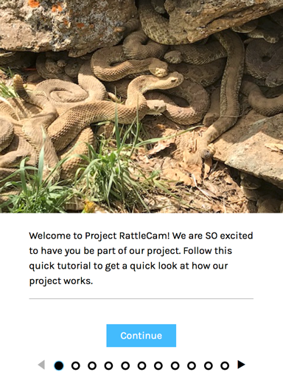

How can you get help with questions not covered in the Field Guide?

Phew! You are now ready to classify photos!

3. Select the “Let’s go!” icon or the “Task” icon to begin classifying images.

4. Your first image will be displayed for you to analyze. Take a moment to familiarize yourself with the zoom and moving around the photo.

5. Be systematic in how you scroll through the photo to search for any visible snakes or other organisms. Don’t forget to disregard shed skins and the data logger.

6. For each image you will be prompted to answer a series of questions about your observation in the task window to the right of the photo. After answering each question select “Next” to answer the next question. The “Next” icon will not appear until after you have made your selection, and after the final question you will click “Done.”

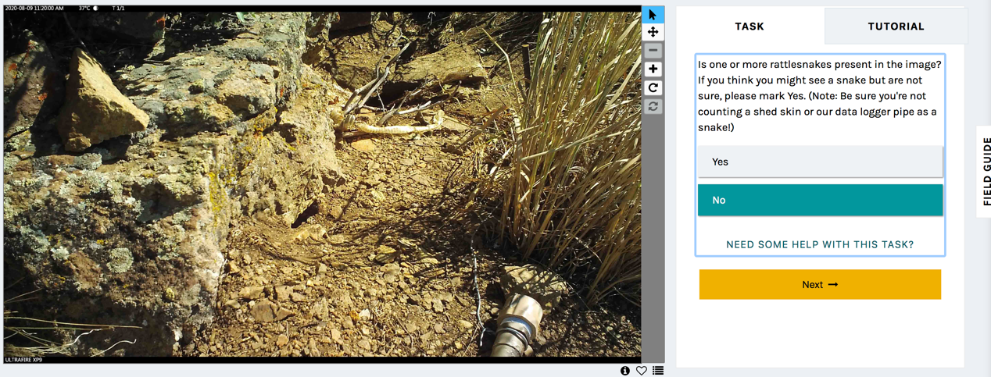

7. Once you have selected “Done” a summary of your classification will appear. Select “Next” to advance to another photo and complete your next classification.

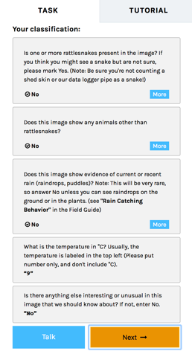

9. Complete at least 30 classifications. Don’t forget to be systematic in your search through each image to make sure you thoroughly look for snakes.

10. Once you have finished with your assigned classifications select the dropdown menu next to your user name and select “Profile.”

11. Once you have navigated to your profile page select “Your stats.”

12. Scroll to the top of your stats page and you will see a summary of your classifications with an image of your classifications by project. You will take a screen shot, like the example below, that includes both these items and submit the image along with your completed lab worksheet to the Canvas assignment.

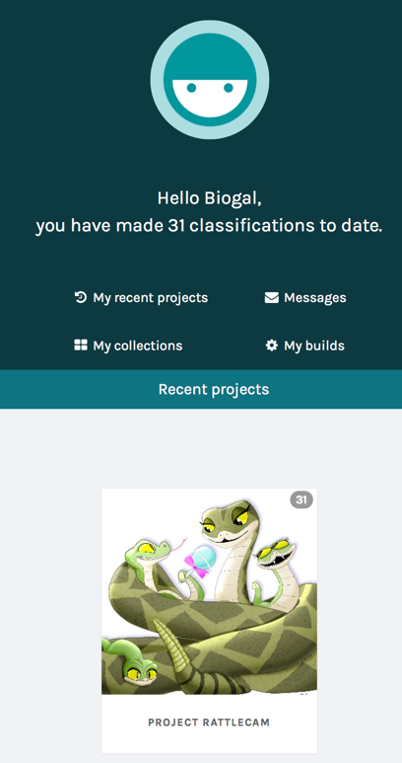

Wow, look at you contributing to science! How does it feel to have contributed to a newly launched research project? Reflect on your experience.

The Project RattleCam team has requested that you share any cool or interesting photos you come across in your classifications on their social media sites. They ask that you post a screenshot that includes the top left portion of the photo that includes the date and time stamp and tag them on the post. This will allow the team to stay up to date on new and interesting data that community members are discovering and help build awareness about their project to interest more volunteers. You can also follow the project to keep tabs on what scientists (and community members) are learning about this population of Prairie Rattlesnakes.

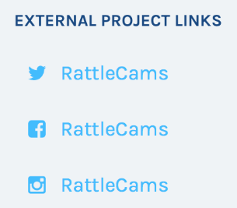

This assignment was initially prepared by Leticia Gallardo of West Valley College and beta-tested by her students. It was later edited by Project RattleCam scientists Julia Perez, Madi McIntyre, and Emily Taylor.

